CHICAGO TRANSIT AUTHORITY
Office of the Secretary

NOTICE OF ETHICS COMMITTEE MEETING

March 4, 2010

Notice is hereby given that a Meeting of the Ethics Committee of the Chicago Transit Authority will be held on Wednesday, March 17, 2010, at 9:30 o'clock in the forenoon at the offices of the Chicago Transit Authority, 567 West Lake Street, Second Floor, Boardroom, Chicago, Illinois, for the purpose of considering:

Matters relating to the CTA’s Ethics Code

and to discuss any other matters that may properly come before the Committee at that time.

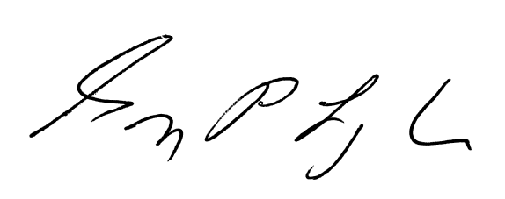
GREGORY P. LONGHINI
Assistant Secretary
Chicago Transit Board

